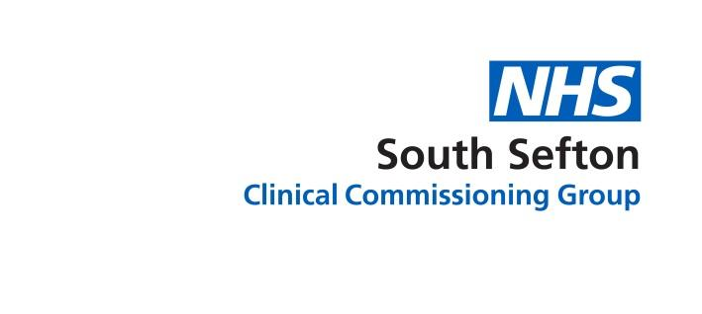
WEB COPY
Grab a jab at Seaforth Village Surgery

Seaforth Village Surgery will be open on Thursday 22 July as a COVID-19 vaccination site for all south Sefton residents who can either walk in for their jab or book an appointment.
The new vaccination site, being run by GP practices in Seaforth and Litherland known as a primary care network, will be offering jabs until the end of August following a successful pilot earlier in the year.
Seaforth Village Surgery will be open for walk-ins or appointments Tuesday – Saturday from 10am to 6.30pm. If people do want to book they can call 07979 938 229 or book via their own GP practice if they are registered with a GP in south Sefton.
The various other ways you can get your vaccination in Sefton are:
- Visit nhs.uk for the up to date grab a jab walk-in sites
- Book an appointment at one of the Sefton pharmacy-led vaccination sites or at one of the 1,600 vaccination centres across the country via the national booking service online: uk/covid-vaccination or by calling 119
- Book direct with the Aintree Hospital Hub: https://aintreeuniversityhospital.nhsbookings.com/v2/#book/service/7/count/1/provider/any/
People who attend a walk-in clinic for their first dose will have their vaccination record updated online and will then be able to book in their second dose appointment using the national booking system.
Second jabs are also available at some of the walk-ins, if it has been at least eight weeks since the first dose and you can check which are offering both doses on the CCG website.
Getting the second dose is vital to getting longer lasting and maximum protection offered by the vaccines, with recent research also showing they are highly effective against the Delta strain of the virus.
Patients are reminded that although COVID restrictions ended in England on 19 July that when they are visiting healthcare facilities they must continue to wear a face covering and follow social distancing rules to protect themselves, other and vulnerable patients and staff.

